The opportunity
The Northern Territory Government is seeking Requests for Detailed Proposals (RFDPs) from suitably qualified parties (Proponents) to construct and operate a seniors’ lifestyle accommodation community in the Darwin Urban area, in the Northern Territory, Australia (the Project).
The Territory Government’s vision is for the provision of purpose-built housing options in a safe community environment. Senior Territorians who live independently in their own home will remain in the Territory and be able to transition into appropriate accommodation by ‘downsizing’ or ‘rightsizing’ if they wish.
The Territory Government is also interested to ensure that the operating structure for delivery of such residences maximises consumer protections.
The RFDP process will provide a flexible framework to deliver a high quality and commercially sustainable project.
The Territory Government encourages suitably qualified developers, land owners, operators and investors to submit innovative and compliant proposals for this unique investment opportunity.

Darwin and the Territory
The Territory occupies about one-sixth of Australia’s total land mass, with a population of over 247,000 and is home to some of the natural world’s most unique and exciting destinations.
The Territory is an attractive place to live - with diverse landscapes ranging from the lush green tropics, waterfalls and cultural landscapes of Litchfield and Kakadu, to the savanna woodlands surrounding Katherine, through the golden plains of Tennant Creek, and the red sandy desert of Uluru/Kuta Juta.
The capital city Darwin, is located in the Arafura Sea and is home to around 146,000 people. It is a lively coastal city well-known for its world-class natural environment, cultural experiences such as the Darwin Festival and Glenti Greek Festival, and emerging café scene. Darwin Harbour, two times larger than Sydney Harbour, offers a range of recreational water activities including year- round fishing and sailing.
Darwin is a welcoming city with networks of inclusive vibrant communities, and a culturally diverse population with over 100 nationalities living harmoniously in one place.
People living in Greater Darwin enjoy a unique tropical lifestyle with light traffic; short commutes and extensive network of cycling and walk paths on generally flat terrains, often along scenic coastal routes or through open green spaces. In addition Darwin has an extensive and affordable bus network.

The Territory, Australia
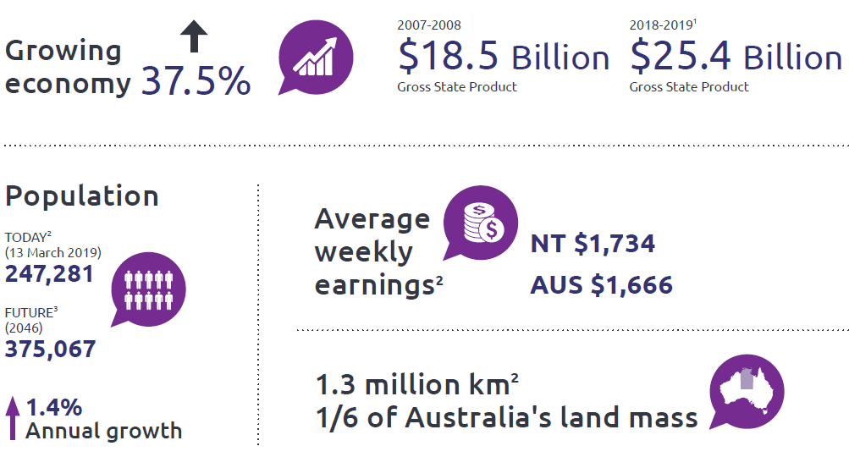

Why Seniors’ Lifestyle Accommodation in urban Darwin
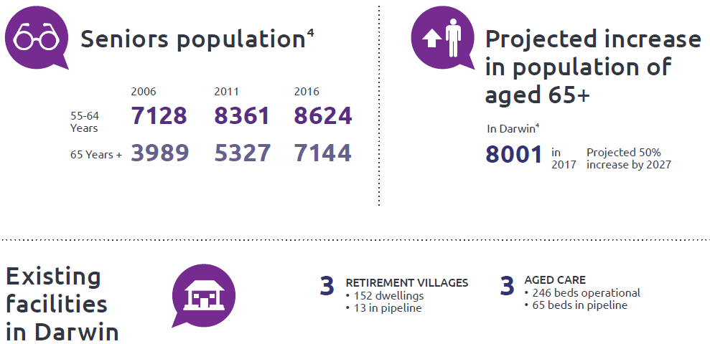

The market for the Darwin Urban Seniors’ Lifestyle Accommodation Project
The NT Population Growth Strategy 2018-28 acknowledges that pre-retirees and seniors are the fastest growing group in the Territory’s population, yet research indicates a progressively larger group in this age bracket is migrating out of the Territory each year. In addition to livelihood and lifestyle opportunities, planning transition to retirement and the availability of quality and affordable seniors’ lifestyle accommodation will help the Territory retain this important population segment.
Senior Territorians have clear expectations around specifically-designed residential accommodation options and are becoming more discerning and sophisticated about the choices available to allow them to live independently within a safe community environment, with access to increasing levels of care and community support as they age.
In April 2017, the Territory Government announced in the 2017-18 Budget the allocation of $500,000 to undertake the first stages of progressing the development of seniors’ lifestyle accommodation in Alice Springs, the Darwin Urban area and the Darwin Rural area.
In 2017, KPMG was engaged by the Department of Trade, Business and Innovation to:
- investigate traditional and emerging senior accommodation models
- undertake market analysis through desktop investigations and consultations with stakeholders, local and Territory Governments.
The key findings of the KPMG Report for the Darwin Urban area included:
- a current undersupply of senior accommodation
- a current undersupply of aged care beds
- target market
- key stakeholder insights.
The Territory Government has prepared an Information Memorandum based on the KPMG Report. The Information Memorandum will be made available to qualified Proponents (refer to the Registration section on page 6).

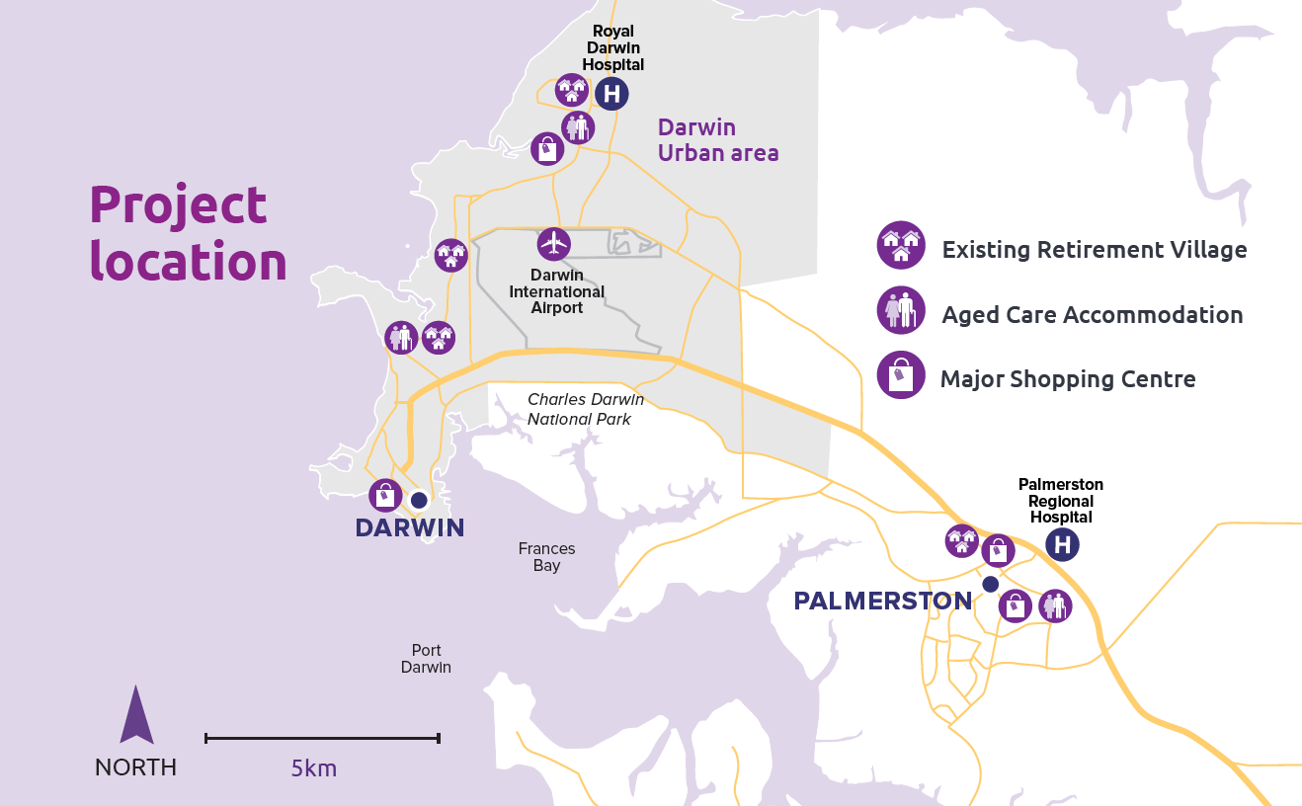

Opportunities
The Territory Government has commenced the Competitive Process to facilitate bringing forward private sector delivery of the Project.
The Territory Government may consider proposals that identify a requirement for the Territory Government to provide support in order for the Project to be economically and commercially viable.
There is no preconceived view as to the kind or level of support which may be granted, but the Territory Government would look more favourably on proposals that minimise the requirement for Territory support and cap the amount of that support.
Proponents will undertake their own due diligence of the Project to determine if it will be a horizontal and/or vertical development; the number and type of accommodation; the price points, the delivery model; and identify the site. In addition, Proponents can also determine if the retirement community is to be co-located with residential aged care facilities for continuity of care; and/or small scale commercial, retail and community uses (such as childcare, medical and professional services). However, the Project is required to contain a retirement living component.
Innovative models of design for seniors’ accommodation in urban settings, nationally and internationally, may provide inspiration for proponents. An example of a retirement living development in a tropical setting is the Kampung Admiralty which is Singapore’s first integrated retirement community project by the Housing and Development Board. It won one of the world’s most prestigious architectural awards – Building of the Year at the 2018 World Architecture Festival. Kampung Admiralty is an 11-storey complex of two residential blocks of about 100 studio apartments. It comprises public housing for seniors who are aged 55 and above, integrated with healthcare, wellness and eldercare facilities and a childcare centre.
Other examples of urban seniors’ developments are:
- the Stafford Lakes Retirement Community in Brisbane’s north, which is both a horizontal and vertical development; and
- Oak Tree Retirement Villages operate in Queensland, New South Wales, Victoria and Tasmania and focus on providing affordable accommodation options.
The Territory Government will establish an online forum for parties such as developers, investors, land owners and/or operators to register their interest in collaborating with others in respect of the Project.

Your proposal
The Territory Government invites proposals which address the Territory’s requirements for the Project and which demonstrate a clear understanding of the Territory’s following objectives:
- increase the number of Territorians choosing to live and remain in the Northern Territory following retirement, by broadening the range of quality accommodation choices available to retirees
- contribute to urban Darwin’s attractiveness as a retirement location by providing modern community living appropriate for aging in place and suited to the local environment and demographics
- deliver an operating framework which maximises consumer protections and preserves value for Senior Territorians
- is sustainable in terms of the financial model under which it is delivered.

Project timelines
The Territory Government is keen to progress the Darwin Urban Seniors’ Lifestyle Accommodation Project. Indicative timelines for the six month RFDP process are:
RFDP registrations open 8 May 2019
RFDP secure website opens 14 May 2019
RFDP registrations close 16 August 2019
RFDP closes 14 October 2019 (4pm ACST)
Announcement of RFDP outcome Q4 2019/Q1 2020

Registration
Interested parties must register through business.nt.gov.au/darwinseniors
The Territory Government will satisfy itself that any interested party seeking to register is a bona fide Proponent and is likely to deliver the project.
The Territory Government may seek any further information from the interested party that it deems necessary and conduct such due diligence checks as it seems fit.
Parties registering interest will be advised of the outcome of their application within three business days of registering.
The Territory Government reserves the right in its absolute and sole discretion to accept or reject registration applications.
Additional information about the RFDP and the project will be made available to Proponents that have registered their interest in the Project and have been accepted by the Territory Government as Proponents. The additional information available includes:
- details of what the Territory Government seeks from Proponents through the RFDP process
- guidance on the evaluation criteria that will be used to assess RFDP proposals
- the Information Memorandum.

Lodgement of RFDP and enquiries
Proponents will need to complete and lodge all necessary RFDP documentation by no later than 4.00 pm (Australian Central Standard Time) on 14 October 2019.
Proponents will be able to submit enquiries through the website business.nt.gov.au/darwinseniors
General enquiries in relation to the Project should be emailed to seniorsaccomm@nt.gov.au
May 2019

NT Budget 2018-2019 - NT Economy
Northern Territory Economy Snapshot, March 2019
NT Population Projections (December 2017)
KPMG 2017 Report.

