Adopting an outcomes approach and the Social Outcomes Framework

Document title | Adopting an outcomes approach and the Social Outcomes Framework
Contact details | Department of the Chief Minister and Cabinet
Approved by | CEO Department of the Chief Minister and Cabinet
Date approved | October 2021
Document review | Biennially
TRM number | <NA if not required>

Version | Date | Author | Changes made
1.0 | March 2021 | Anne Coleman | First version

Contents
1. Introduction 4
2. Understanding Outcomes 4
2.1. Outcomes architecture 4
2.2. What are outcomes? 5
2.3. Types of outcomes 5
2.3.1. Time-frame 5
2.3.2. Outcome level 6
2.4. Identifying outcomes 6
2.5. What is an outcomes approach? 7
2.6. Benefits of an outcomes approach 7
3. The Social Outcomes Framework 8
3.1. Purpose of the Framework 8
3.2. Social Outcomes Framework - Domains 8
3.3. Using the Framework 9
4. Using outcomes 10
4.1. Getting the most out of an outcomes approach 10
4.2. A learning culture 10
5. How to create change 11
5.1. Program Evaluation Framework 11
5.2. Deciding what data to collect 11
6. Collaboration to achieve change 12
Appendix A: Glossary 13

Introduction
The NT Government is committed to an outcomes approach in the way it delivers public policy and services.
This guide is an introduction to an outcomes approach and the Northern Territory Social Outcomes Framework (the Framework). It sets out practical steps for adopting an outcomes-focused approach and provides an overview of the Framework. The guide can be used by both NT Government agencies and organisations.

Understanding Outcomes

Outcomes architecture
Achieving meaningful change requires a shared understanding and common language. An outcomes approach provides a consistent way to design and measure outcomes. The Framework’s architecture
Figure 1: Framework architecture
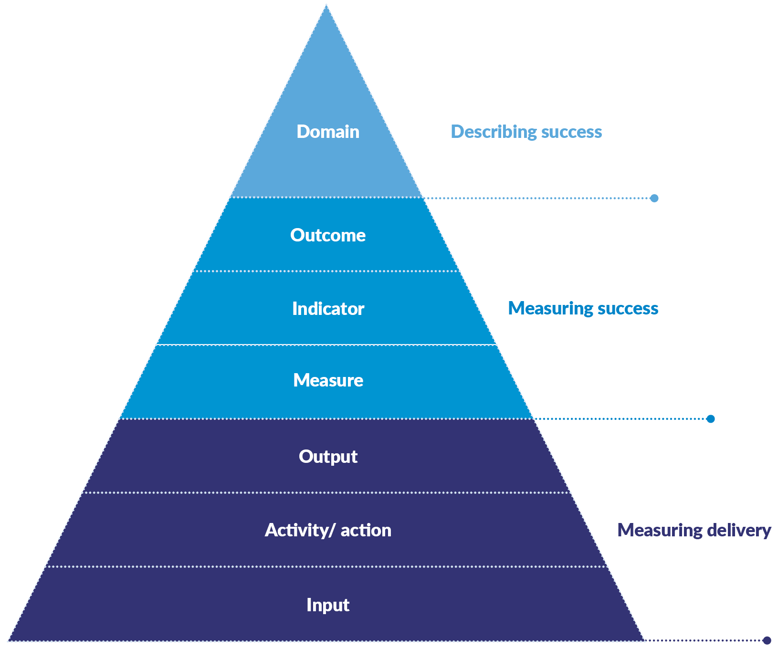
helps provide consistency in language as well as shows how to identify and measure progress towards priorities for the Northern Territory.
The Framework’s architecture (Figure 1) contains the following elements:
- domains describe success with an aspirational statement of what we want to achieve, and work across traditional policy areas
- outcome statements shows the required change and articulates what success looks like for all individuals, families or communities
- outcome indicators describe what needs to change to achieve the outcome and sets the direction of change required
- outcome measures quantify the size, amount or degree of change required.

What are outcomes?
An outcome describes the changes or differences that happen as a consequence of a policy, program, service or activity being delivered. These changes occur for individuals, groups, families, organisations, systems, or communities during or after an activity. Outcomes can include a shift in attitudes, values, behaviours or conditions and demonstrate genuine social progress.

Types of outcomes

Time-frame
Outcomes can be short, medium or long-term (see Figure 2):
- short-term outcomes are the most direct result of an activity
- medium-term outcomes link an activity’s short-term outcomes to long-term outcomes. These may take some time to become noticeable
- long-term outcomes are the result of achieving the short and medium-term outcomes. They usually occur beyond the timeframe of the activity and are often influenced by a range of factors.
There are no particular time-frames relating to short, medium and long-term outcomes. They refer to the time-sequence or the order in which different outcomes are achieved.
Short-term outcomes are the more immediate outcomes over which individual NT Government agencies and organisations have the most direct influence.
Medium and longer-term outcomes take longer to achieve and are likely to be those where an NT Government agency or organisation has less direct influence and to which multiple NT Government agencies and organisations make a contribution over a more sustained period of time.

Figure 2: Hypothetical example of how outputs link to short, medium and long-term outcomes (for children not meeting developmental milestones)
Outputs | Short-term outcomes | Medium-term outcomes | Long-term outcomes
Play-based activities e.g. reading, games, outdoor play  Parenting workshops on varying topics e.g. navigating service system, parenting skills  Information and referrals provided to families | Parents increase skills and confidence to provide stimulating play activities for their child  Parent increase their social networks and social skills  Parents increase knowledge of developmental milestones  Parents improve knowledge of support services | Parents more skilled and empowered to support child’s development  Improved parent/ child relationships  Improved child/child relationships Parents feel an increase in connection to community  Parents access support services when needed | Children reach developmental milestones  Parents are resourced and empowered to support children’s cognitive, social and emotional development  Family wellbeing is enhanced

Outcome level
Outcomes can also be defined at different levels, such as the population, region, system, program, service, or the individual level (see Figure 3).
Although the Framework is based at the population level, it still provides the architecture to determine and align outcomes at any level. The system, program and client level outcomes are measures of shorter term outcomes and provide important information required to establish a clear line of sight between inputs, outputs and longer-term outcomes. There should also be a clear line of sight from the outcomes of a service or program to the region or population outcomes. The Framework assists in making these pathways clearer.
At a system, service or program level, outcomes may also relate to improvements in how services are implemented or delivered.

Identifying outcomes
A program logic is a way to understand a system and a common way of defining, and visually representing the outcomes that will occur as a consequence of program activities. A program logic identifies the intended causal links between the inputs, activities and outputs and the short, medium and long-term outcomes.
Figure 3. Hypothetical example of outcome levels (for families with young children engaging in a parenting program)
Outcome level | Outcome
Population outcome | All NT children are ready to enter the education system and learn
Program outcome | Young children engaged in the program reach their learning potential
Service delivery outcome | Families with young children engage in early learning and parenting services

It is important to identify and define the required level when developing appropriate outcomes. In the short-term, what is the scope of the change required by a program or service? The size and scope of a service will affect the outcomes that it can achieve and measure. It is very unlikely a service will be able to achieve population based outcomes as outlined in the Framework. However, a service should contribute to the achievement of one or more of the outcomes at a localised level and should understand how it will impact or connect to the outcome at a population level in the longer term.

What is an outcomes approach?
An outcomes approach means changing the way you measure progress to measuring outcomes as the results of activities, rather than measuring inputs or outputs. A focus on outcomes helps organisations demonstrate to stakeholders that what they are doing in terms of policy development, program design and service delivery and how they are approaching the activity is working. More importantly, it also helps organisations improve what they are doing, by being equipped with better information to take lessons learned into account.
An outcomes approach means identifying what data to collect, so an NT Government agency or organisation has the right information and evidence base available, regarding what is working and what is not, and can this information be used to improve program design and delivery (see Section 5). For many NT Government agencies or organisations, adopting an outcomes approach means a significant and concerted shift in focus.
The first step to understanding what outcomes an NT Government agency or organisation is trying to achieve is to answer the question “Why are we doing this?”
Secondly, the focus needs to be on what are the changes or differences we want to see, and needs to be achieved not just on the program, service or activity delivery. This means developing and delivering activities in line with the desired broader outcomes the NT Government agency or organisation want for people in the long term. The performance against those outcomes are then measured to answer the question “Is what we’re doing working and progressing in the right direction?”

Benefits of an outcomes approach
Some of the benefits of implementing an outcomes approach for NT Government and partners delivering activities in the community are:
- It leads to greater change – an outcomes approach encourages NT Government agencies and organisations to be clear about the impact they want to have, and then test, learn and amend to ensure their policies, programs and services are effective. This iterative process can improve service design and delivery, foster collaboration to achieve shared goals, and drive innovation, that ultimately leads to better human services outcomes.
- Innovation (change) is encouraged – if there are no changes in particular indicators over time, NT Government agencies and stakeholders will be encouraged to investigate current approaches and systems and develop new ways of addressing challenging problems.
- Progress can be monitored – indicators are linked directly to outcomes to give visibility regarding what progress is being made.
- Resources can be aligned to outcomes – programs showing good progress towards outcomes can be expanded or duplicated, programs not meeting outcomes can be reviewed.
- Responsibilities can be identified – a transparent mapping of outcomes, indicators and measures allows responsibilities and ownership of indicators to be assigned. Using the Framework also enables joint accountability for outcomes across NT Government agencies and partnering organisations.
- Increased collaboration and minimisation of duplication – all interested parties are focussed on the same outcome and can align efforts.

The Social Outcomes Framework

Purpose of the Framework
The Social Outcomes Framework (the Framework) recognises the values the community associates with individual and community wellbeing. It provides a transparent approach for the NT Government and its partners, including the non-government organisation sector and the community, to measure progress towards a broad, aspirational vision for the future of the Northern Territory.
All Territory individuals, families and communities are inclusive, healthy, safe, resilient and thriving

The Framework is a tool which provides a clear and consistent focus on identified priority outcomes that governments, organisations and the community can use to collectively measure progress.
The Framework focuses on social outcomes at the population level. It does not include outcomes relating to access to services and facilities, rates of participation in programs or services, or individual client outcomes.
While use of the Framework is not currently mandatory, and there is no associated reporting requirements, NT Government agencies and organisations are encouraged to use the Framework to support policy development and the design, delivery and evaluation of the services, programs and activities they deliver. The Framework can also assist the planning, design and implementation of evaluations required under the Program Evaluation Framework by providing a set of agreed outcomes, associated indicators and measures to track progress overtime.

Social Outcomes Framework - Domains
The Framework has seven domains (Figure 2) defined by a statement of intent. The chosen domains reflect the range of social outcomes that affect the wellbeing of all Territorians. There are a number of high-level key outcome statements under each domain in the Framework.
Initially the number of priority outcomes (and therefore the associated indicators and measures) in the Framework are limited, to ensure progress occurs and that the Framework is focussed, and best placed to be embedded into systems. As progress is achieved, new outcomes can be added into the Framework.
Figure 2: Framework domains
Territorians are able to live a healthy life
Territorians have appropriate and secure housing
Territorians are connected to culture and community
Territorians are able to learn, contribute and achieve
Territorians are safe
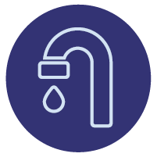Territorians are financially secure and have material basics
The Territory has a natural and built environment that supports a high quality of life

Using the Framework
The Framework supports NT Government agencies and organisations to adopt an outcomes approach by setting out the social outcomes that the NT Government is working towards.
The Framework provides:
- greater clarity around what the NT Government’s target outcomes are and a way to demonstrate how NT Government agencies and organisations are contributing towards those outcomes
- context for how activities, programs or services support the long-term social outcomes
- a way to increase awareness of possible linkages within and across domains.
NT Government agencies and organisations should use the Framework to identify which outcomes and domains in the Framework their policy and program activities will contribute towards.

Using outcomes

Getting the most out of an outcomes approach
The main aim of an outcomes approach is to use the evidence to learn and improve the way policy is developed and activities, programs and services are delivered. Measuring what matters most is only part of the story; real change comes through building a culture that understands how to use the data to then produce outcomes.
It is vital to review the results of your outcomes measurement regularly to see whether things are working as you thought they would. This will help ensure the intended change is achieved. Is the data confirming that you are achieving your intended outcomes, or is it showing that you have mixed results in achieving your outcomes? Is the data showing that you are realising outcomes that you did not expect?
A useful way to review the evidence is in line with the original program logic. Some helpful questions to ask are:
Policy Issue:
- Have you understood the issue appropriately?
- Is the issue you identified impacting on individuals in the way you thought it would?
Stakeholders:
- Are you reaching the intended cohort?
- Are you reaching as many people as you expected?
- Is there something you can do to better reach your target group?
Activities:
- Are you delivering activities in the best way to achieve the intended outcomes?
- Is the format of the activity appropriate? Is the location appropriate?
- Are you delivering the right mix of activities? Are there activities you might want to stop delivering?
Outcomes:
- Are you achieving the outcomes you intended?
- If you are having mixed results with outcomes, look for the cohorts, geographies, or activities where you are doing well. What is it that is resulting in better outcomes?
It can be helpful to ask questions and critically analyse the areas where you are not doing well. What is it about those areas that are not working well? Are you also hearing that you are achieving outcomes that aren’t in your logic model, whether positive or negative?

A learning culture
An NT Government agency or organisation with a learning culture focuses on doing what it does as well as it can and continually seeks to do better. A learning culture values honest appraisal and constructive feedback. It considers the relevant context of an assessment and makes difficult decisions based on evidence, even if that means changing or ending a program.
Learning about what doesn’t work is as valuable as learning about what does. Taking time to identify, discuss and learn from failure provides critical knowledge to inform future decisions. Deliberate reflection on experience is essential and should be encouraged. This provides the opportunity to recognise any failings early. If something isn't working – be prepared to stop! There is a tendency to continue investing in an activity because of the resources that have already been invested without realising the opportunity to re-think the policy or activity.
Just identifying what information to collect, does not mean that people will collect and use that information effectively. NT Government agencies and organisations should strive to develop a culture of tracking performance against outcomes (and not outputs), appropriate evaluation and informed decision-making.

How to create change
An NT Government agency or organisation needs to be clear about what it is trying to achieve. Specifically, NT Government agencies and organisations need to know whether their policies and programs are delivering what they’re intended for. There is a risk that without adopting an outcomes approach, poorly designed policies and underperforming programs may continue without change, and not contribute towards achieving the desired outcome and not contribute to public value.

Program Evaluation Framework
An outcomes approach complements the NT Government’s Program Evaluation Framework. The Program Evaluation Framework integrates evaluation requirements into policy and budget development processes and provides Government agencies with the necessary guidance to plan, commission and use evaluations to ensure programs are achieving the desired outcomes.
The Program Evaluation Framework refers to long-term outcomes as impacts.
The Program Evaluation Framework promotes the use of a program logic and the Program Evaluation Toolkit outlines the process to develop a program logic. There are a number of different tools that can be used to develop a program logic and link inputs and outputs through to outcomes.

Deciding what data to collect
The priority outcomes from a program logic model need to be translated into measurable elements that can be monitored. A set of measures that will provide data about progress towards the outcome that needs to be identified. The selected measures should have a clear linkage to the desired outcomes, be validated and practical. The information should also be able to guide decision-making and inform service delivery. The measures should also be appropriate to the level of the outcome, for example a population level measure should be used for evaluating the outcomes of a policy and not be used for an individual service or program.
Measures should not dictate indicators.
Some helpful questions to ask are:
- How is the community/stakeholder/client better off as a result of this policy or receiving the program/service or activity?
- How will we know the community/stakeholder/client is better off as a result of this policy or receiving the program/service or activity?
- Is the measure understandable? - is it meaningful to, and likely to be perceived as important by the community and stakeholders?
- Is the measure comparable? Is the data available for sociodemographic and different cohort populations that allows assessment and comparison?
- Is the measure robust? (i.e. statistically appropriate and fit for purpose)
- does it measure what its intended to measure?
- will it allow change over time to be detected?
- is it available or readily collected?
- is it vulnerable to perverse incentives or unintended consequences?

Collaboration to achieve change
The Framework encourages NT Government agencies and organisations to work towards the same goal:
- within NT Government agencies - an outcomes approach allows agencies to have greater clarity around what they want to achieve.
- between NT Government agencies - the Framework encourages agencies to think about how their efforts contribute to long-term outcomes that are outside their direct control. For example, how does housing contribute to education or health outcomes? If all NT Government agencies and organisations recognise the direct and indirect impact of their policies and activities, they may discover more opportunities to support each other in achieving their collective goals. All parties can contribute to the broader outcomes.
- between those who fund services and those who deliver services - a focus on outcomes is a way to better align the objectives of those who fund services, and those who deliver services with a sense of shared purpose. The Framework invites funders and service providers to work together to develop the most effective ways of achieving sustainable outcomes.
- between those who deliver services and communities - a focus on outcomes supports a more holistic and innovative response to achieving outcomes for the community. The Framework proposes the long-term population outcomes that services should aim for, but leaves open the program, service and individual outcomes. These outcomes can be co-designed with communities to ensure services are responding to the needs and wants of the community.
- between those who deliver services and individuals - an outcomes approach lends itself well to co-designing services with individuals and working with them to achieve the outcomes they want. It supports strengths-based, goal oriented service delivery which makes the client an integral part of the solution. When an individual is part of the goal setting, they will be more invested in achieving the outcomes.

Appendix A: Glossary
Term | Meaning
Activity | What we do to deliver the service – programs, services, everyday work
Domain | Groups related outcomes – and provides line of sight from each outcome. The NT Domains have been derived from several key sources
Evaluation | A systematic and objective process to make judgements about the merit or worth of one or more programs, usually in relation to their effectiveness, efficiency and appropriateness The NT Government has a Program Evaluation Framework to guide the evaluation process.
Indicator | Specifies what needs to change to achieve the outcome and set the direction of change. Can also have a target specified
Impact | The change in outcomes for those affected by a program compared to the alternative outcomes had the program not existed. May also refer to longer term outcomes.
Input | The resources or investment allocated to deliver activities (funding, staff, infrastructure)
Measure | Provides the specific detail about what will change and how you know that you are making progress
Organisation | Includes both for-profit and non-government organisations
Outcome | Shows the required change or difference, articulates what success looks like. (Outcomes can be short, medium or long-term. Outcomes can also be at a different level e.g. population or program level)
Output | What is counted to measure the delivery of an activity or service– e.g. number of activities, products, clients
Perverse incentives | A perverse incentive is an incentive that creates an unplanned, negative and unwanted consequence. For example, organisations only working with individuals who are likely to demonstrate change quickly. Perverse incentives are a type of unintended consequence.
Policy | Is a deliberate system of guidelines to guide decisions and achieve outcomes. It is a statement of intent and is implemented as a procedure or protocol.

Adapted from https://aifs.gov.au/cfca/sites/default/files/example_of_a_completed_program_logic.pdf
The Program Evaluation Toolkit explains how to develop a program logic. https://treasury.nt.gov.au/dtf/financial-management-group/program-evaluation-unit/toolkit/complete-the-evaluation-overview
Program evaluation framework - Department of Treasury and Finance
https://treasury.nt.gov.au/dtf/financial-management-group/program-evaluation-unit
https://treasury.nt.gov.au/dtf/financial-management-group/program-evaluation-unit/toolkit
See glossary, page 12
https://treasury.nt.gov.au/dtf/financial-management-group/program-evaluation-unit/framework-and-toolkit

